XMEye客户端应用Client Application

1. 下载安装APP：Download and install APP

方法一：扫描设备开机向导中的“手机客户端”二维码或设备系统“版本信息”中的“手机客户端”二维码快速下载并安装APP；

Method 1: Scanning device boot wizard in the "mobile client" two-dimensional code or device system "version information" in the "mobile client" two-dimensional code quickly download and install APP

方法二：在手机应用商店（如Google Play、App Store）里搜索“XMEye”,下载并安装；

Method 2: Search "XMEye" in mobile application stores (such as Google Play, App Store), download and install

方法三：从设备供应商处获取；Get from equipment suppliers

1. 用户注册登录：User registration and login

APP安装成功后，在手机程序列表点击XMEye应用软件图标，启动软件并运行。

After APP is installed successfully, click the XMEye application icon on the list of mobile phone programs to start the software and run it.

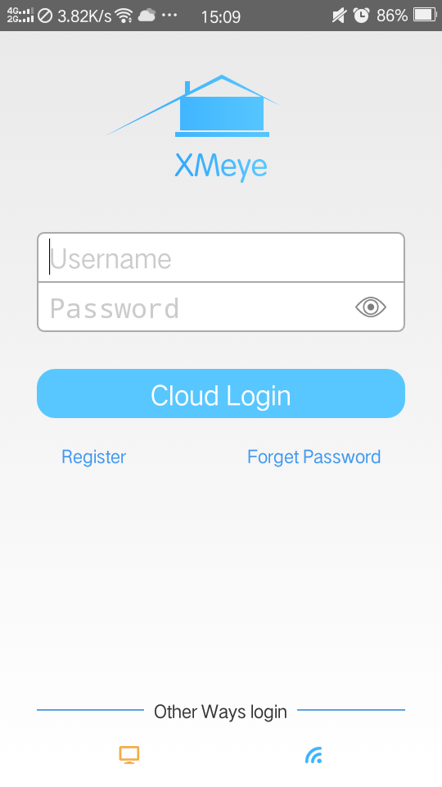

1. 用户注册：（如果已注册拥有用户账号则可直接跳过此步骤）

user registration: (if you have registered user accounts, you can skip this step directly).

1.1选择“用户注册”项，进入到用户注册页面，如下图：

Select “Register” to enter the user registration page, as shown below

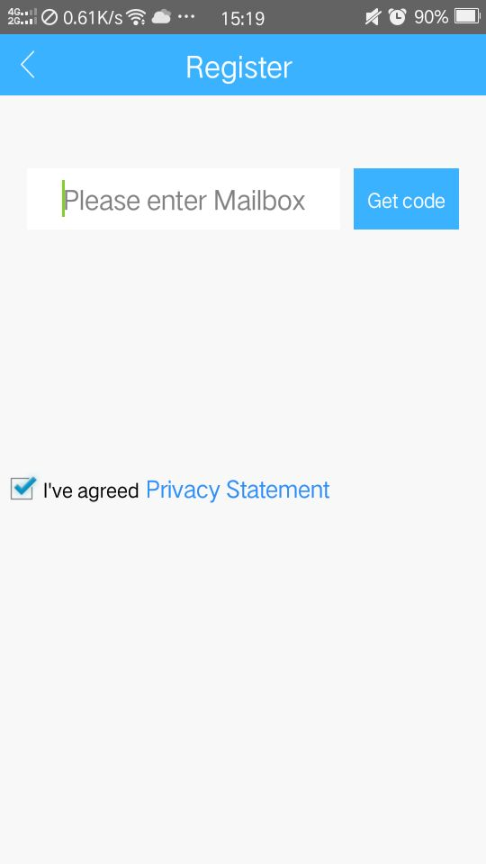

* 1. 输入本人注册使用的手机号或邮箱地址，并点击“获取验证码”，如下图：enter the mobile phone number or email address I registered, and click "Get code"

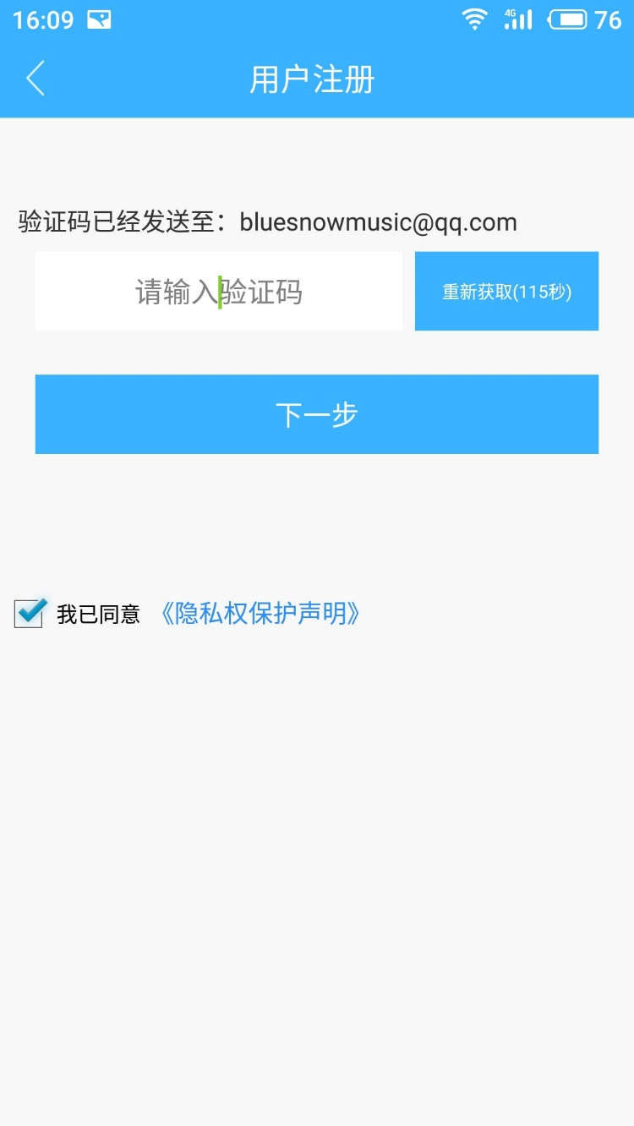

* 1. 输入手机或邮箱接收到的注册验证码，点击下一步，如下图：Input the registration verification code gotten by mobile phone or mailbox, click next

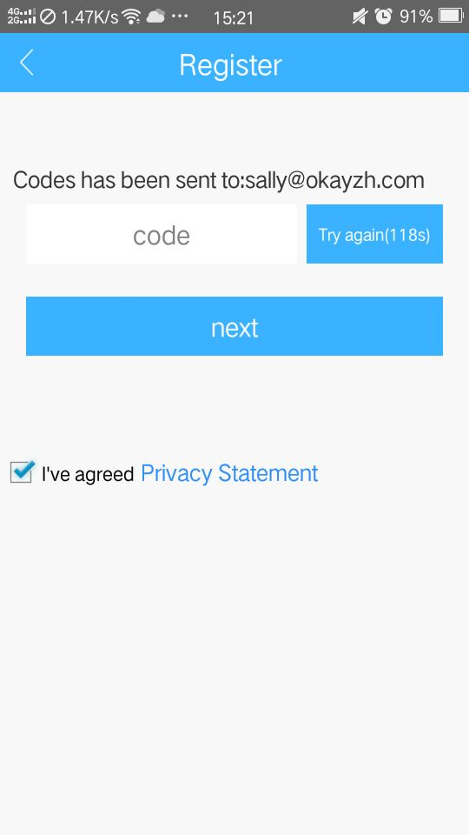

* 1. 在用户注册界面按要求填入用户名、密码、确认密码，并确定，完成用户注册。Fill in user name, password, Confirm for confirmation password and Click [OK] in the [Register] interface as required, and complete the user registration.

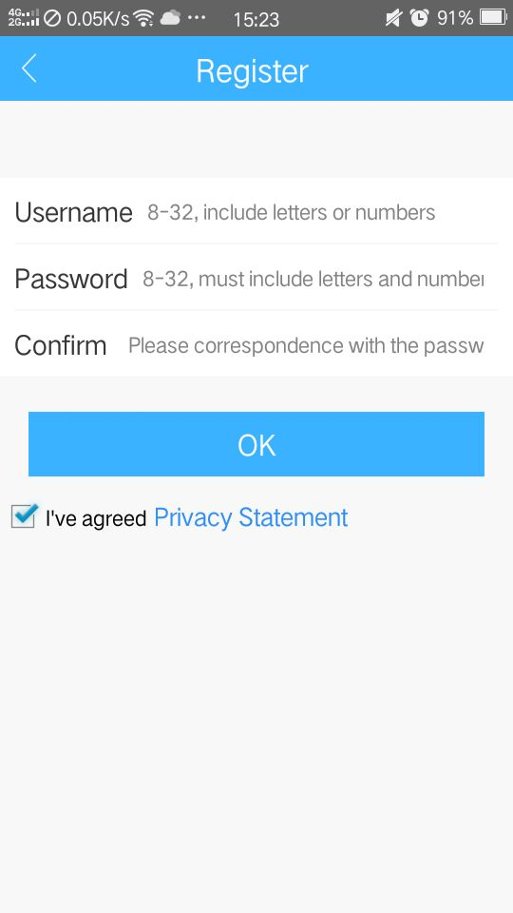

1. 用户登录：User login

2.1.在APP用户登录界面，输入用户名和密码，选择“云登录”，如下图： In the APP user login interface, enter the user name and password, select "cloud login", as shown below

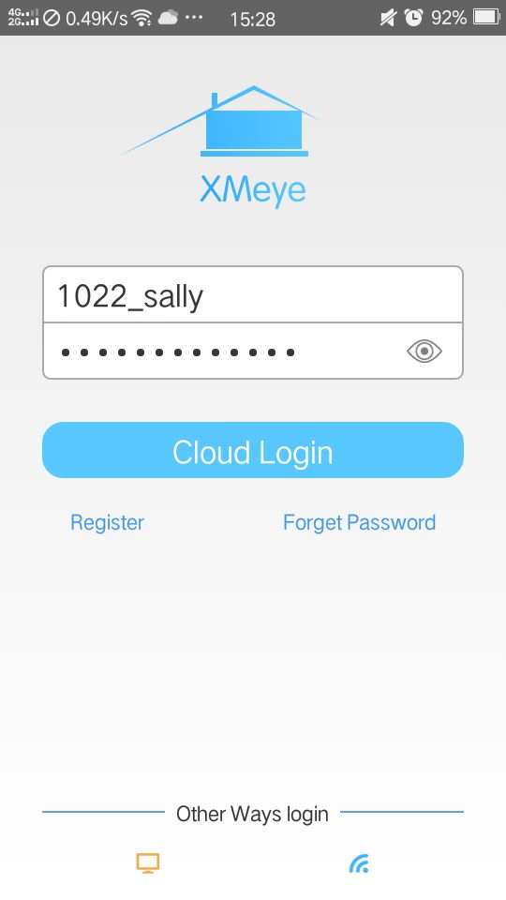

2.2用户登录完成后，进入到“设备列表”界面，如下图：

After login, the user enters the "device list" interface, as shown below

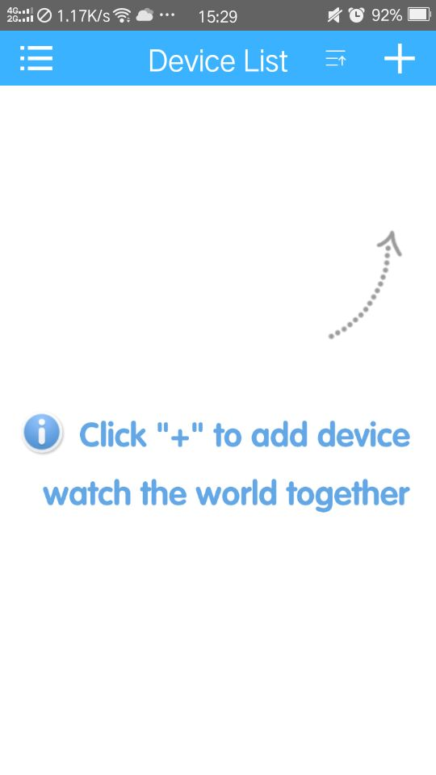

1. 添加并连接设备：Add and connect devices.
2. 添加设备：Add devices

1.1用户登录成功后，即进入到该用户账号的设备列表界面，如下图所示：

After login successfully, the user enters the device list interface of the user account, as shown in the following figure.



点击“设备列表”右上角的“＋”按钮进入“添加设备”界面，默认显示手动添加页面，如下图：Click the C:\Users\Administrator\AppData\Roaming\Tencent\Users\1251686593\QQ\WinTemp\RichOle\T{AP1M6G)M%GHP$EH8`{[TB.png button in the upper right corner of the Device List to enter the [Add Device] interface. The default display is the Manual Add Page, as shown in the following figure

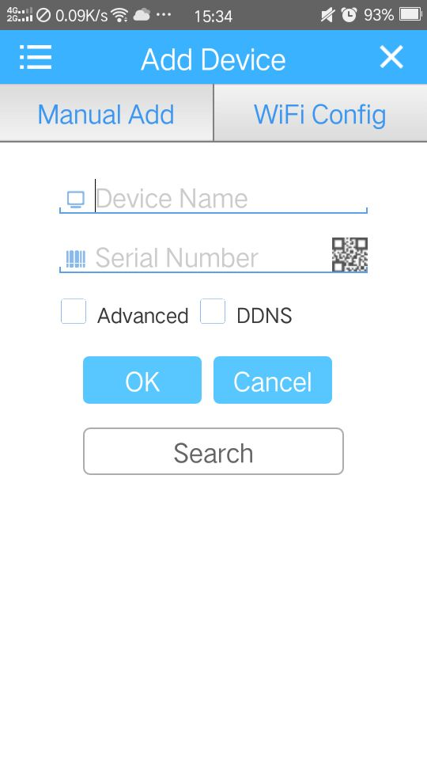

* 1. 在添加设备界面，输入设备名称、设备序列号（序列号可从设备的系统版本信息或者开机向导的设备序列号二维码中获取，输入时也可以点击输入框右侧的二维码按钮进行二维码扫描输入），如下图：In [Add Device]interface, enter the device name, serial number (serial number can be obtained from right click and enter [Main menu]>[Advanced]>[Version] to find the Serial number or right click and enter [Guide]>[Next]>[Next] to scan the Serial No QR code , as shown below

1. 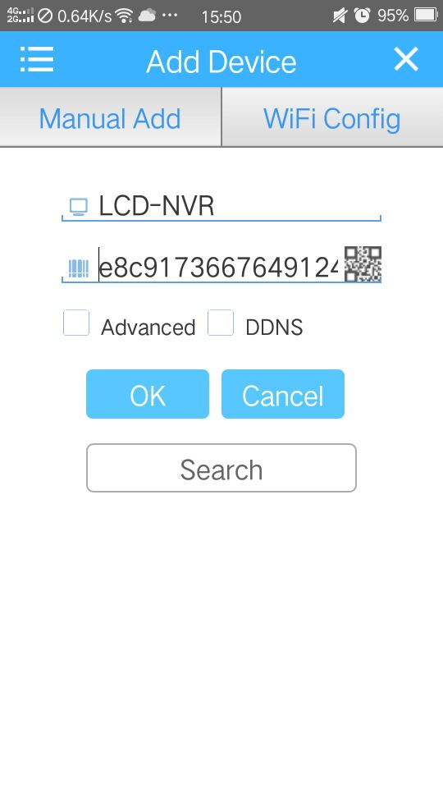
   1. 点击“确定”，完成设备添加。Click [OK] to complete the device addition
2. 设备连接：Device connection
   1. 在设备列表界面，选择已添加的设备并勾选，如下图：In the [Device List] interface, select the added devices and check them as follows
3. 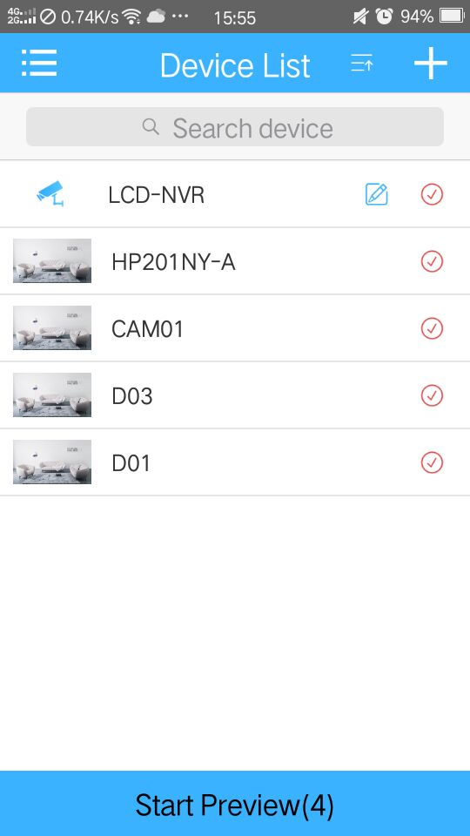
   1. 点击页面下方的“开始预览”字样，进入实时视频界面，如下图：click on the word "Start Preview" below the page to enter the real-time video interface, as shown below
4. 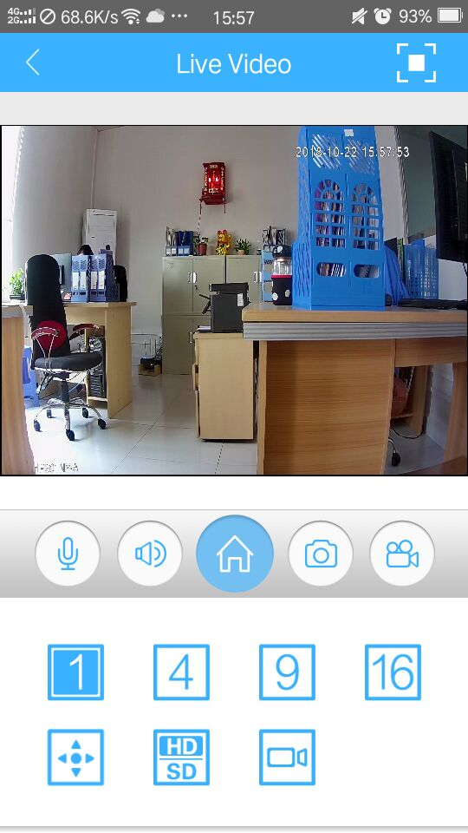
5. 远程录像回放：Remote video playback
6. 在实时视频预览页面，选择录像回放图标，进入远程回放界面：In real-time video preview page, select Video playback icon to enter remote replay interface

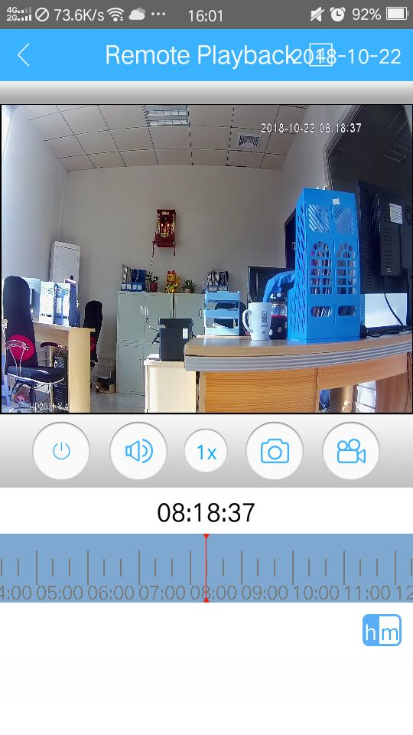

1. 选择远程回放界面右上角的日期和视频回放下方的时间进度条，选择需要远程回放的录像时间点，并进行录像回放观看。Select the date in the upper right corner of the remote playback interface and the time bar in the video playback side, select the video time point that needs remote playback, and watch the video playback.
2. 报警推送设置和语言切换：Alarm push setup and language switching.

设备列表界面点击“”进入主菜单界面Device list interface Click,enter main menu interface

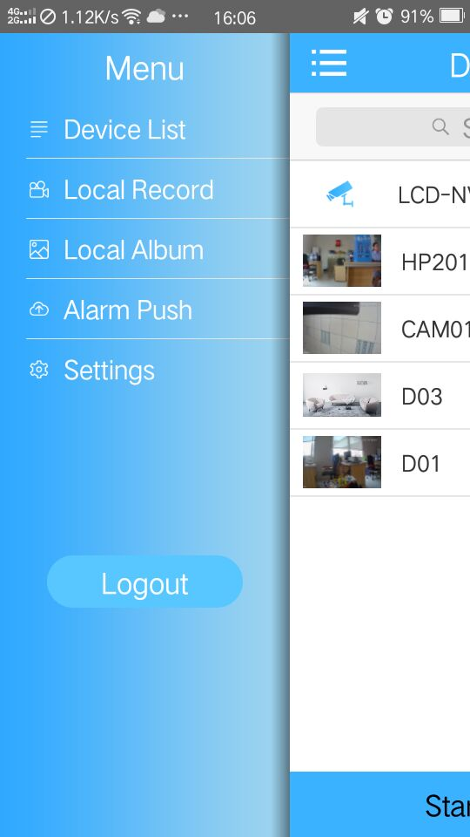

1. 报警推送设置：alarm push settings

在“主菜单”项选择“报警推送”，并将对应设备右侧的报警推送开关设置为“开”，当设备触发报警时，手机会发送信息及声音，如下图所示： Select "Alarm Push" in the "Main Menu" item and set the alarm push switch on the right side of the corresponding device to "On". When the device triggers an alarm, the mobile phone sends messages and sounds, as shown in the following figure

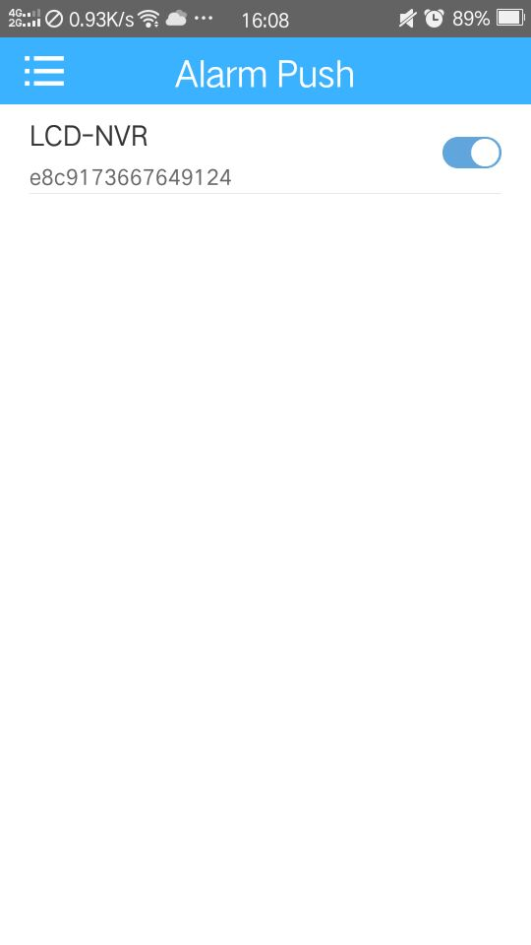

1. 语言切换：Language switching
   1. 当手机操作系统更换语言时，软件的语言会随着更换。例如：手机操作系统语言更换为英文，那么手机软件的语言也会随着更换为英文。When the mobile operating system changes the language, the language of the software will be changed automatically. For example, if the operating system language of the mobile phone is changed to English, the language of the mobile software will be changed to English as well.
   2. 也可在APP主菜单中选择“设置”-“通用”，在“语言”项中选择对应的语言进行切换，如下图：You can also select [Settings] – [general] from the main menu of APP and select the corresponding language in the "Language" tab to switch, as shown below
2. 